Interdisciplinary Project
A defining moment in my life was fueled by a grueling process of a medical emergency. When I had just turned 15 I had been experiencing extreme pain in my left arm, it once got so bad I could not pull up my pants. We decided to get an X-ray of my arm for further evaluation, and it was a good thing we did so. When we got a call back from the doctors we were told I had a tumor in my left arm, this led to a meeting with an oncologist and a biopsy on my left humerus the very next day. Throughout the process I was intimidated and scared, however, through the process I learned a lot about myself, what I stood for, and what my perspective on the world was. After the biopsy it was determined that it was not cancer, and after a year of confusion we learned that it is CRMO. Chronic recurrent multifocal osteomyelitis is a very rare disease and what they were looking at on the X-ray was how my bone was growing around in order to protect my body from the inflammation going on. This is what I would describe as my defining moment in history because it totally flipped my world upside down, changed my perspective on life and helped me better realize who I am as a person. Although a very stressful and scary time period, I am grateful for the experience as it truly humbled me as a person, and helped me grow.
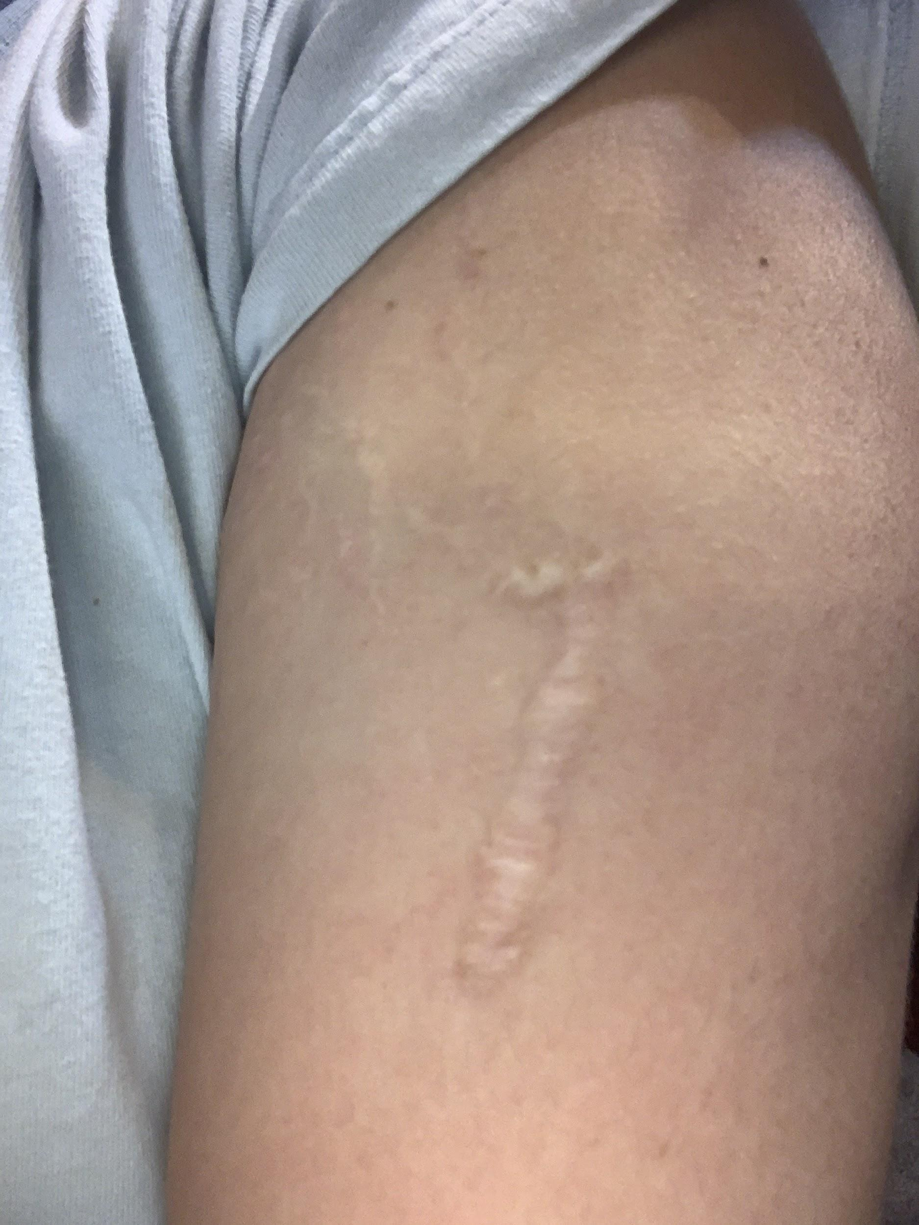(The arm I had my biopsy on)
The defining moment within my grandmother's life was not out of the ordinary. My grandmother grew up in Mexico, and came to the United States early on in her life, speaking spanish as her first language. She stated that english was very hard for her to learn but was slowly gaining experience in the language, however, as she persevered she was still having trouble specifically in school. This is when her english teacher came to her aid, and thus providing her with a defining moment in her life. This high school english teacher, accommodating my grandmother's struggles, offered her to read an entertaining magazine in english instead of the textbook. After she was done reading the magazine, the teacher would talk to her about it, made sure she understood it and helped her find joy in learning this new language. The teacher knew they couldn’t and wouldn't get my grandmother very far in her education if they chose to make her read the textbook instead, so they decided to turn learning english into something enjoyable for her. My grandmother felt as though she had someone looking out for her, and someone who was really willing to help her learn, not just throw a textbook in her face and tell her to figure it out. My grandmother appreciated this teacher's kindness and understanding greatly, feeling as though she had gained knowledge towards the language, while not stressed over it. This defining moment in my grandmother's life would never fade away from her memory, as she still remembers the great deal of emotion and gratitude towards the teacher for their accommodation.
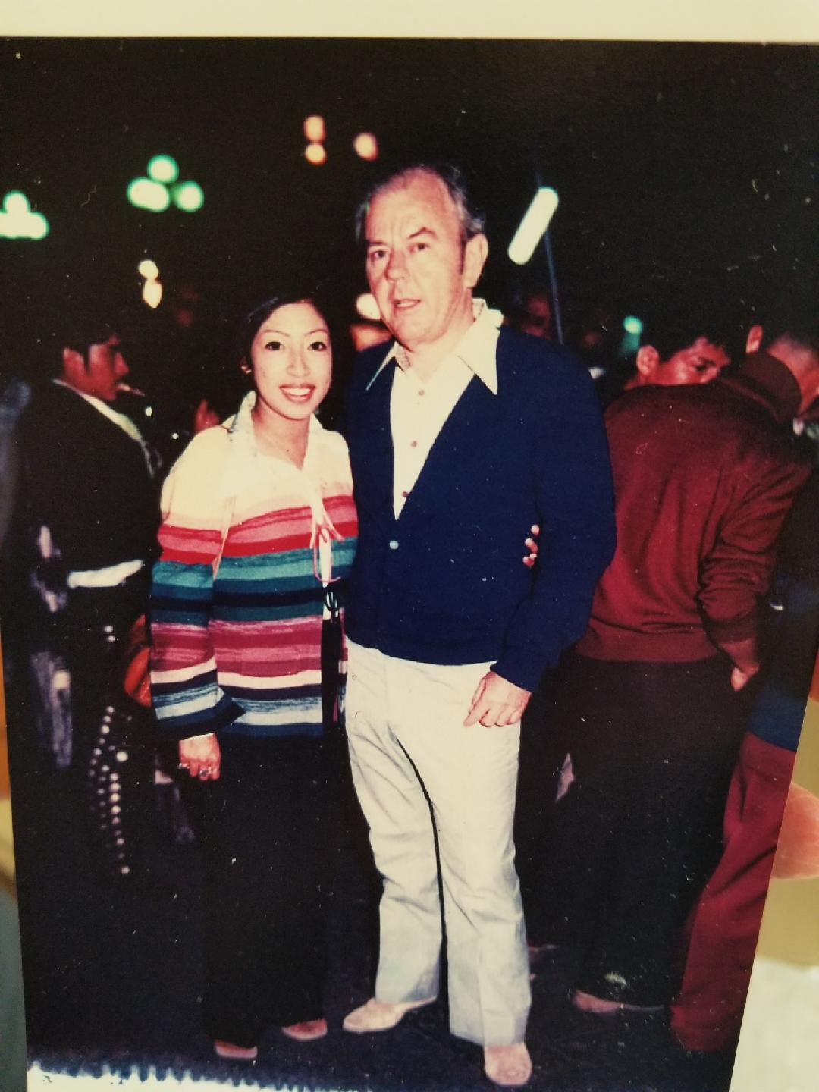(My grandmother is on the left).

